Partial symmetry in modular structures

B. Stöger¹

¹X-ray center TU Wien, Getreidemarkt 9, 1060 Wien, Austria

bstoeger@mail.tuwien.ac.at
Crystalline materials are often understood as being three-dimensionally periodic (or quasi-periodic) arrangements of atoms. According to an alternative, phenomenological, definition crystals feature an essentially discrete diffraction pattern. However, in the early days of structural analysis, diffraction patterns were recorded that featured discrete (indicating order) and diffuse (indicating disorder) regions (Fig. 1). To explain this phenomenon, the order-disorder (OD) theory was developed in the 1950s [1]. OD structures are built according to strict geometrical rules, yet are not necessarily periodic and are ubiquitous across all classes of materials. They comprise of modules (layers or rods), such that pairs of adjacent modules are always equivalent. In proper OD structures, there are an infinity of possible arrangements that are locally equivalent. Thus, the OD theory is a generalization of crystallinity taking into consideration the “short-sightedness” of matter (i.e. the short range of interatomic interactions). The symmetry of OD structures is given by a space groupoid of partial isometries [2]. Examples of OD structures and more general cases of locally equivalent modular structures are discussed. In particular, it is shown how such modular structures may lead to homometry (distinct structures resulting in the same diffraction pattern [3]) even for simple and realistic growth models (Fig. 2). In contrast, homometry is exceedingly rare in periodic structures.
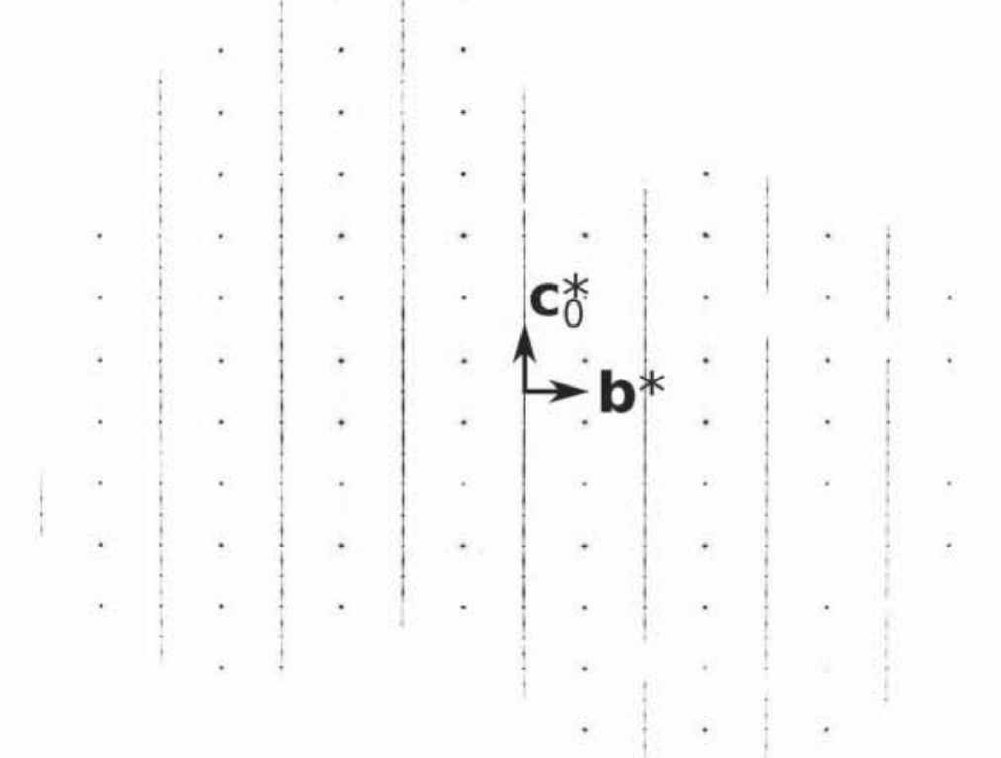

Figure 1. h = 1 plane of reciprocal space of a MgTeO₈H₈, showing discrete (“ordered”) and diffuse (“disordered”) parts.

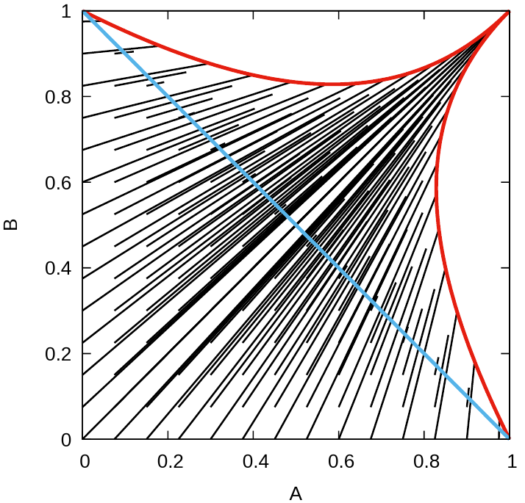
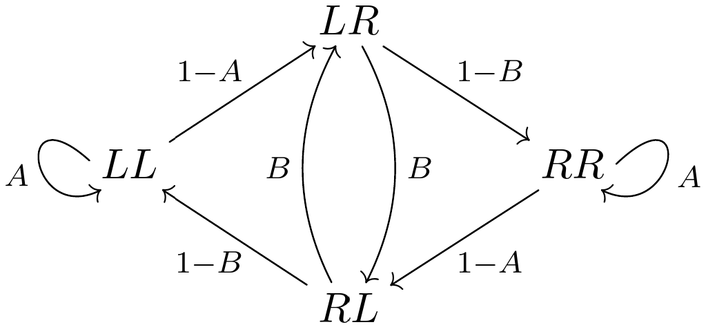
Figure 2. Left: Two-neighbor growth model with transition probabilities A and B (L and R are translations with +¼a and −¼a components, respectively). Right: Homometric pairs (A, B) connected by black line segments. The blue line represents parameters degenerating to a single-neighbor model.

[1] Dornberger-Schiff, K. & Grell-Niemann, H. (1961). Acta Cryst. 14, 167–177.

[2] Fichtner, K. (1977). Beitr. z. Algebra u. Geometrie, 6, 71–99.

[3] Zobetz, E. (1994). Cryst. Res. Technol, 29, 379.

